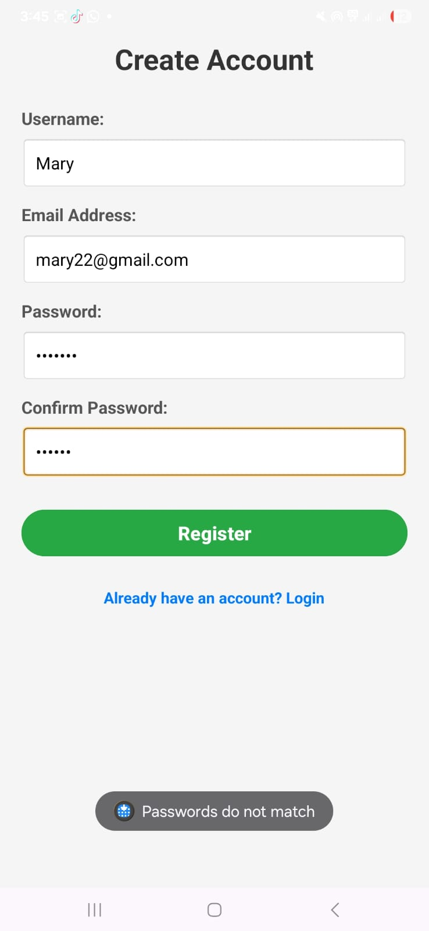
The user should have match the password with the initial password

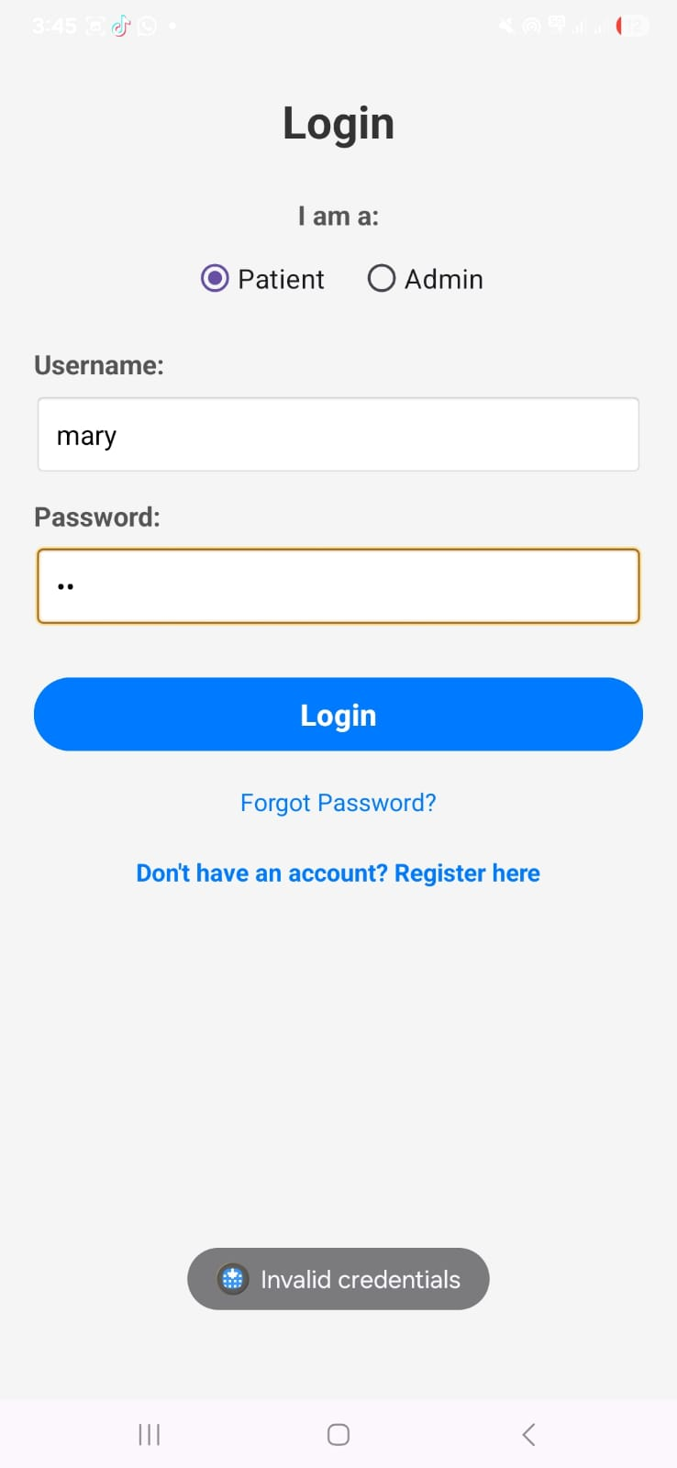
The Patient should log in with the correct password
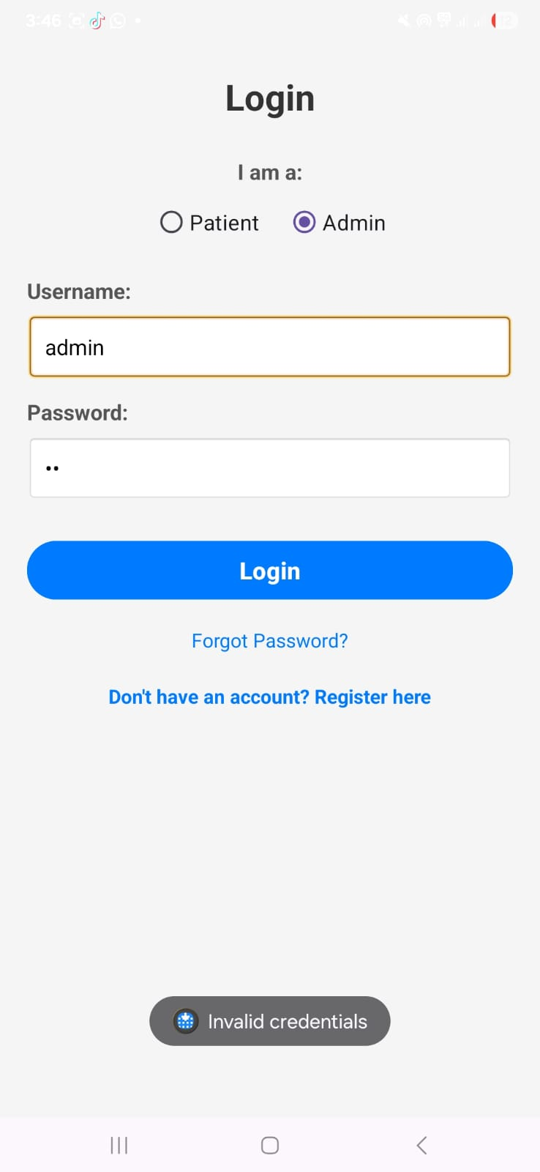
Admin should log in with the correct password

ERROR LOG AND DEBUGGING REPORT (TASK 3)
This document contains a log of errors encountered during the development and testing phase, how they were fixed, and descriptions for your screenshots.
---
ERROR 1: LOGIN ROLE MISMATCH (Logical Error)
- Description: After registering a new user, they were unable to log in despite entering the correct credentials.
- Cause: The registration code was saving users with the role "user", but the login screen was checking for the role "patient".
- Fix: Updated RegisterActivity.java to save all new accounts with the "patient" role to match the login screen selection.
- Screenshot Description: Take a screenshot of the Login screen showing the "Invalid credentials" or "Incorrect role" Toast message at the bottom.
ERROR 2: ACTIVITY NOT FOUND (Navigation Error)
- Description: The app crashed immediately when an Admin attempted to log in and go to the Admin Dashboard.
- Cause: The AdminDashboardActivity was created but not declared in the AndroidManifest.xml file.
- Fix: Added the <activity android:name=".AdminDashboardActivity" /> tag to the Manifest file.
- Screenshot Description: A screenshot of the "App has stopped" error dialog on the emulator (or the AndroidManifest.xml file highlighting the added activity).
ERROR 3: DATABASE NULL POINTER (Data Handling)
- Description: The Service Request form was empty (the dropdown/spinner had no services).
- Cause: The database initialization (onCreate) hadn't finished before the MainActivity tried to load the services.
- Fix: Implemented a check in DatabaseHelper to ensure default services are inserted immediately upon table creation.
- Screenshot Description: A screenshot of the "Service Request" screen showing the "Select Service" dropdown with the correct options (Cleaning, Porter, etc.).
ERROR 4: FORM VALIDATION ERROR (UI Responsiveness)
- Description: Users were able to submit empty service requests, leading to blank entries in the admin panel.
- Cause: Missing "if-else" check for empty Ward and Bed number fields.
- Fix: Added a validation check in MainActivity.java to show a Toast message ("Ward and Bed number are required") if fields are empty.
- Screenshot Description: A screenshot of the Service Request form with a red Toast message saying "Ward and Bed number are required".
ERROR 5: SQLITE COLUMN INDEX ERROR (Data Handling)
- Description: Admin Dashboard crashed when trying to load the list of requests.
- Cause: Using "user" instead of "user_name" in the Cursor query.
- Fix: Corrected the column name to "user_name" in the loadRequests() method.
- Screenshot Description: A screenshot of the Admin Dashboard showing a successful list of patient requests.

